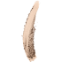 | 01 - Nude Beige  Item# Z026251  - Add to Wishlist
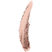 | 02 - Nude Pink  Item# Z026252  - Add to Wishlist
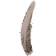 | 03 - Taupe  Item# Z026253  - Add to Wishlist
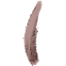 | 04 - Rosewood  Item# Z026254  - Add to Wishlist
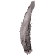 | 05 - Sparkle Grey  Item# Z026255  - Add to Wishlist
 | 06 - Earth  Item# Z026256  - Add to Wishlist

